How to Search for OTL’s Latest Materials in the Catalog

- Navigate to the OTL catalog at https://l92018.eos-intl.net/L92018/OPAC/Index.aspx, OR by going to the OTL main page at https://www.oktl.org/ and clicking on “Catalog.”
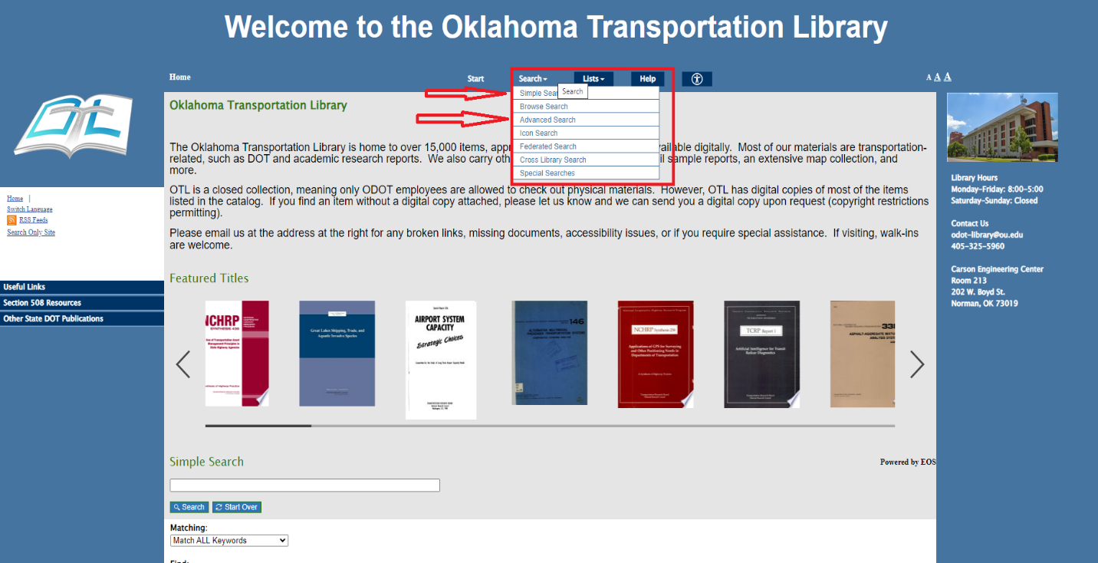
- Select “Search” and choose either “Simple Search” or “Advanced Search.” An advanced search contains more filters for more precise results. See step 3 for a simple search. Skip to step 4 for an advanced search.

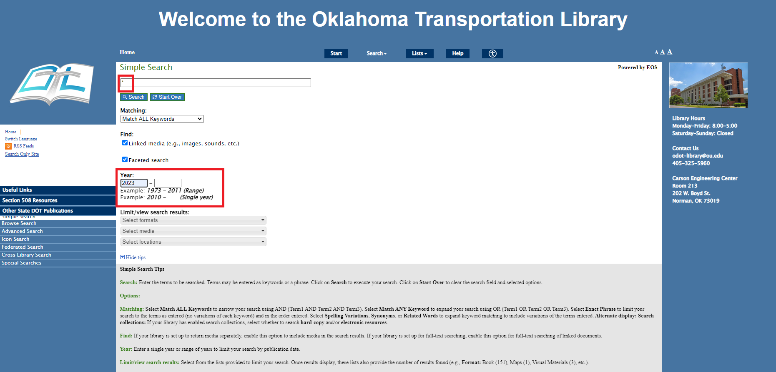
- In a Simple Search - To see all possible items, type an asterisk (*) in the search box. Under the “Year” search box, type the current year in the first box. Click search.

- In an Advanced Search, you have several options.
- Click one of the drop down boxes marked “select field.”
  - Added Date – Search by the date an item was added to the catalog
  - Updated Date – Search by the date an item was UPDATED; for example, a new copy added or more information added to the record
  - Received Date – Search by the date an item was received. Generally, this will be the same day as the added date.
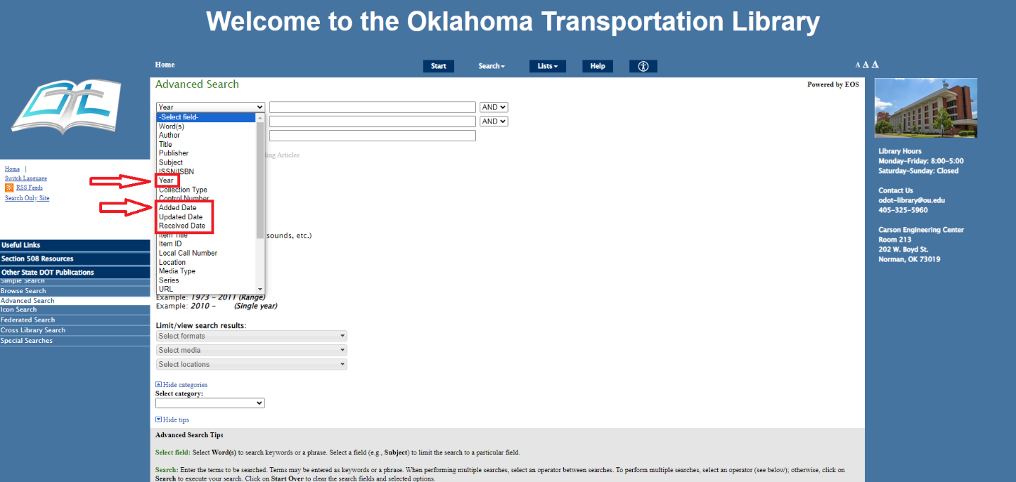
  - Year – Search by year only. You may also perform a year search or a year range search (such as 2021-2023) by scrolling down and using the “Year” search underneath the Advanced Search selections.

- Once you have made your selection, enter any additional information and click “Search.”

